Polish Connection
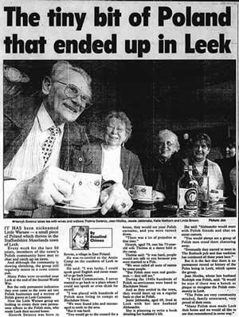
A fascinating and engrossing venture that we have been working on since 2003 is a reminiscence project with the local Polish community, many of whom lived at the camp in Blackshaw Moor, near Leek in the years following the Second World War.
We have done a series of interviews with the original Polish residents and their families and have recorded some wonderful and moving stories, both of life in Poland during the war and the sometimes horrendous journeys that led to a little village in the Staffordshire Moorlands. This archive collection has already led to a large volume of text which has been used to form the basis of a PowerPoint presentation and an exhibition which will travel around the Staffordshire libraries this autumn.
With the help of funding from Market Towns Initiative, in May 2004 Borderland Voices published the book of Polish reminiscence, 'A Long Way from Home'. The book was launched at Leek Library and followed by a celebratory evening organised by the local Polish community.
We are also grateful to County Arts Staffordshire for helping with funding towards the design and printing of 4 permanent exhibition boards covering the Polish Connection project.
This exhibition has already been seen at Leek, Biddulph, Stafford and Hanley libraries and there are plans to show it at other Staffordshire libraries during 2005

